Described as an innovative thinker and a serial entrepreneur, Mr. Michael Slater has been recognized as a leader in event planning and business match making services and is a frequent speaker on the topic of networking. Mr. Slater, Founder of SpeedNetworking.com, has developed a unique method to effectively match business professionals for the advancement of career and/or business objectives. Mr. Slater’s strong desire to elevate and empower professionals in their initiation of new business relationships has made him a highly recognized figure for business professional matchmaking. SpeedNetworking.com has been recognized in the New York Times, Chicago Tribune, Entrepreneur Magazine and several other national publications.

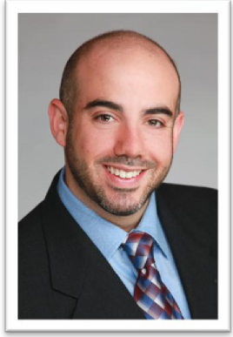 | 
MICHAEL A. SLATER
EXECUTIVE BIOGRAPHY
SLATER@SPEEDNETWORKING.COM
LinkedIn: http://www.linkedin.com/in/speednetworkingusa

Serving as the Founder of SpeedNetworking.com, Mr. Slater is focused on growing the business operations and development of its product and programs. Mr. Slater’s services have been utilized by; IBM, Siemens Corporation, PepsiCo, Halliburton, Bristol-Myers Squibb, Research In Motion (Blackberry), Yale University, New York University, Indiana University, Chicagoland Chamber of Commerce, American Association of Museums, Corporate Compliance & Ethics Association, IBC Life Sciences Association, Chicago Convention and Tourism Bureau and many other high profile organizations.
Prior to SpeedNetworking.com, Mr. Slater served as Director of Business Development for MovingStation where he focused primarily on securing key business relationships. He also worked closely with executive management to explore and launch new business initiatives. Before MovingStation, Mr. Slater previously served in business development roles for Drake Beam Morin (DBM). He focused exclusively on driving new business relationships which promoted DBM’s online career services portal targeting alumni and graduating students of major colleges and universities.
In addition to Mr. Slater’s professional responsibilities, he currently holds a position on the Board of Governors for the Metropolitan Club (A Club Corp Company) in Chicago. He recently served on the Kelley School of Business Alumni Association (KSBAA) National Board of Advisors where he received the highest honor, “Alumni of the Year”. Mr. Slater has also served on the board of the American Heart Association Young Executives and Young Entrepreneurs Alliance. Mr. Slater holds a B.S. in Marketing and Real Estate Finance from the Kelley School of Business at Indiana University. Mr. Slater lives in Chicago with his wife and two children.

